NSS Activity No-01
International Yoga Day Celebration at IIIT-NR
Name of NSS Unit: Dr. SPM IIIT Naya Raipur, Chhattisgarh, India
Name of the District: Raipur
Name of the NSS Program officer: Dr. Krishnanand Vishwakarma/ Dr Lakhindar Murmu
Date of regular activity: 21-06-2025
Brief Description of the Activity: The objective of the International Yoga Day Celebration at IIIT-NR was to promote the practice of yoga and raise awareness about its numerous benefits for physical and mental well-being. The event aimed to provide participants with an immersive yoga experience under the guidance of an expert instructor, Mr. Manjeet Sthapak, a renowned yoga instructor from the Yoga Institute, Raipur. By engaging in various yoga asanas and mindfulness exercises, participants were encouraged to integrate yoga into their daily lives for improved health and relaxation. In this international yoga day, there are more than 60 participations from IIIT Naya Raipur, Chhattisgarh. The capturing picture during the events are shon as below.
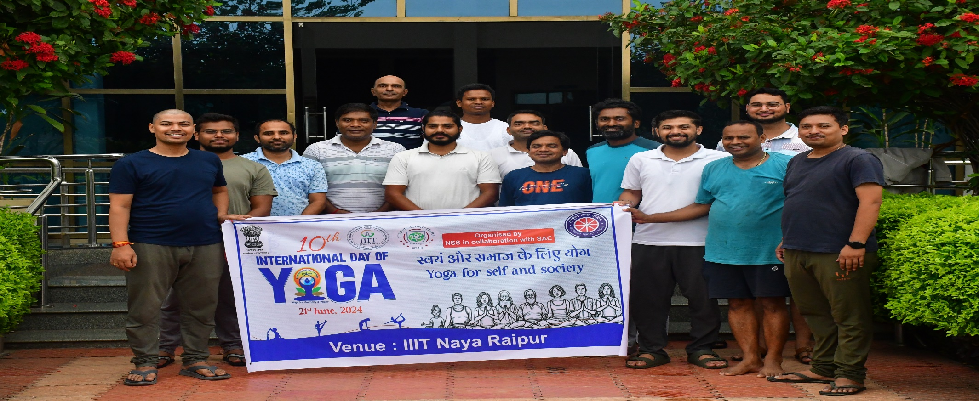
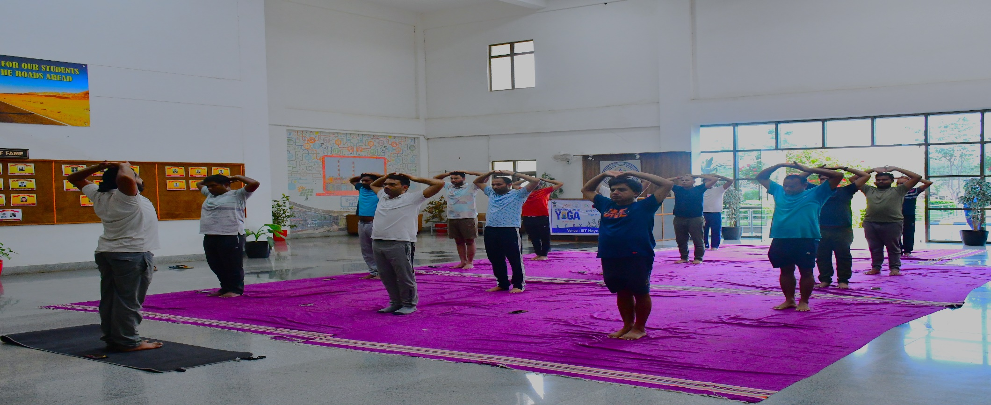
Picture of all participated members
NSS Activity No-02
Participation of IIIT-NR in ANVESHA 2.0 Nationwide Quiz Competition, Raipur
Name of NSS Unit: Dr. SPM IIIT Naya Raipur, Chhattisgarh, India
Name of the District: Raipur
Name of the NSS Program officer: Dr. Krishnanand Vishwakarma
Date of regular activity: 18-07-2025
Brief Description of the Activity: The objective of the ANVESHA 2.0 Nationawide Quiz contest on official Statistics is to put your data awareness, statistical insight, and general knowledge to the ultimatetest. This contest was organized by the Manistry of Statistics & Programme Implemantations(MoPSI), National Regional Statistics Office, Raipur, Chhattisgarh on July18, 2025. In the competation, there more than 180 students are paerticipated from 34 different Institutation/University of the Chhattisgarh State, where the IIIT Naya Raipur got the 9th position. The all statistical officer of CG governement are present during the contest and Dr. Krishnanand Vishwakarma, NSS PO of IIIT Naya Raipur coordinating the IIIT Naya Raipur students. The capturing pictures during the events are shown as below.
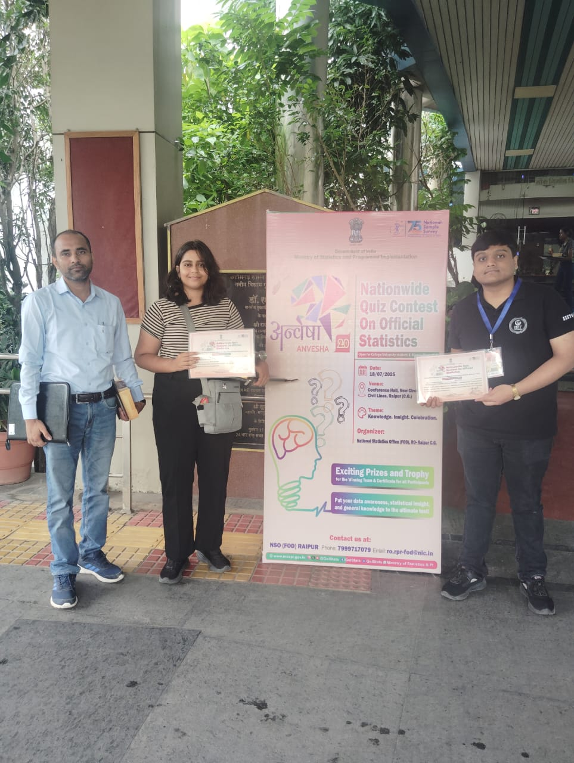
Picture of all participated members
NSS Activity No-03
"Kargil Vijay Diwas" Celebration
Name of NSS Unit: Dr. SPM IIIT Naya Raipur, Chhattisgarh, India
Name of the District: Raipur
Name of the NSS Program Officer: Dr. Krishnanand Vishwakarma / Dr. Lakhindar Murmu
Date of Regular Activity: 28-07-2025
Brief Description of the Activity: The event was graced by Prof. N.P. Dixit, Chairman of the Jammu & Kashmir Ladakh Study Center, as the Chief Guest, along with Shri Deshdeepak Singh, Joint Secretary. The program was conducted under the chairmanship of Prof. Om Prakash Vyas, Director of IIIT-NR, and Prof. K.G. Srinivasa, Dean (Academics). The dignitaries addressed the gathering, highlighting the historical and national significance of Kargil Vijay Diwas and inspiring students to remember the bravery and sacrifice of Indian soldiers.
The ceremony included inaugural remarks and tributes, with active participation from faculty, students, and staff. Mementos were presented to the guests as tokens of appreciation, and the event concluded with a vote of thanks by Dr. K.N. Vishwakarma, NSS Program Officer.
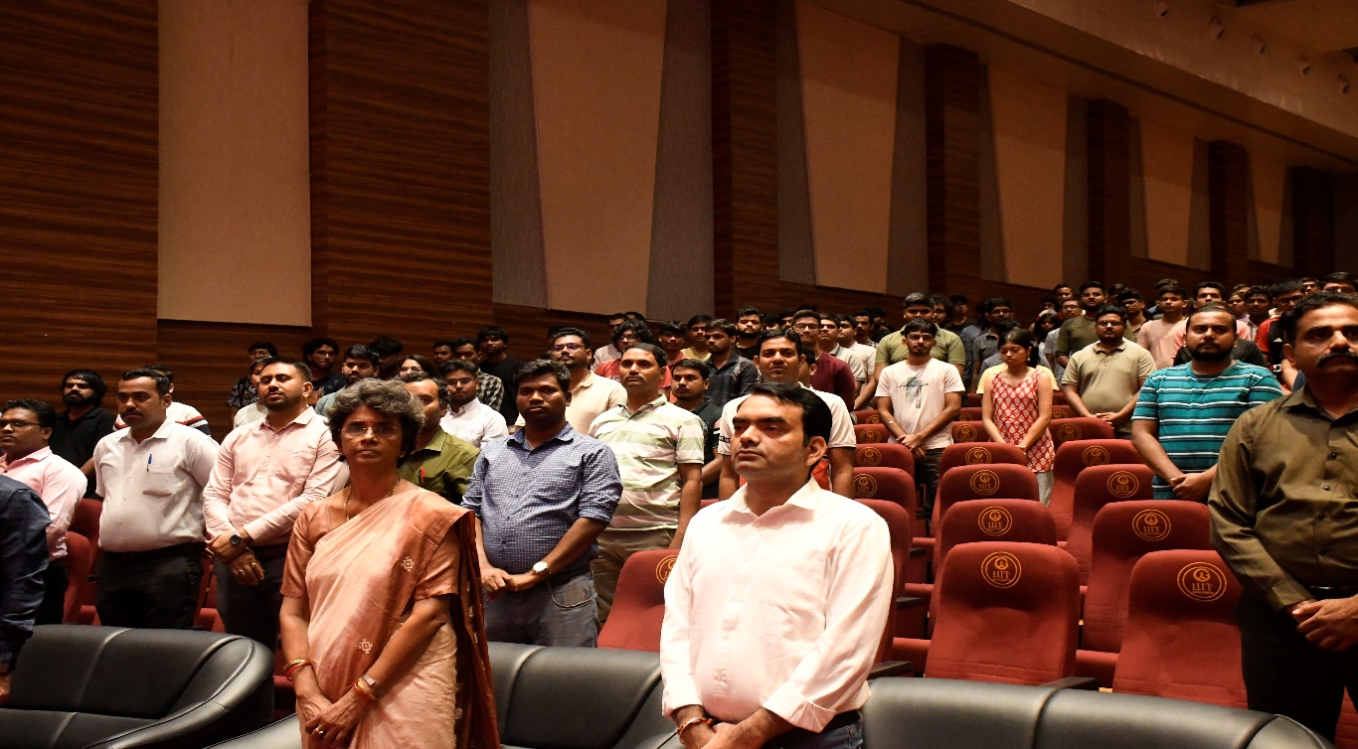

Picture of all participated members

NSS Activity No-04
Independence Day Celebrations at IIIT-NR
Name of NSS Unit: Dr. SPM IIIT Naya Raipur, Chhattisgarh, India
Name of the District: Raipur
Name of the NSS Program officer: Dr. Krishnanand Vishwakarma
Date of regular activity: 15-08-2025
Brief Description of the Activity: The objective of the Independence Day celebration was to commemorate India’s 78th year of independence by fostering a sense of patriotism, unity, and pride among students, staff, and the community. The event aimed to honor the sacrifices of freedom fighters, celebrate the nation’s rich cultural heritage, and promote the values of responsibility and leadership.
The celebration was graced by the Chief Guest, Dr. Om Prakash Vyas, Director of IIIT-NR. The program included flag hoisting, speeches, and various cultural activities that reflected the spirit of independence and national pride. More than 500 participants, including students, faculty, and staff, actively took part in the event. The pictures captured during the celebrations and activities are shown as below.

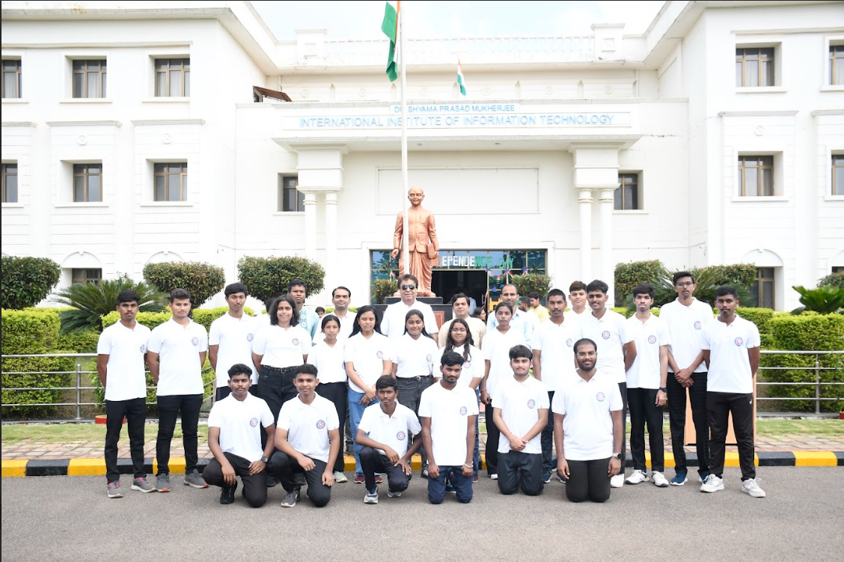

Picture of all participated members

NSS Activity No-05
Plantation drive at IIIT-NR
Name of NSS Unit: Dr. SPM IIIT Naya Raipur, Chhattisgarh, India
Name of the District: Raipur
Name of the NSS Program officer: Dr. Krishnanand Vishwakarma
Date of regular activity: 28-08-2025
Brief Description of the Activity: The objective of the Plantation Drive at IIIT-NR was to contribute to environmental sustainability and raise awareness about the importance of green spaces. The event aimed to involve participants in hands-on tree planting activities, under the guidance of Treewards, to enhance the campus’s green cover and promote a sense of environmental stewardship. By actively participating in this initiative, attendees were encouraged to play a role in ecological conservation and foster a deeper connection with nature. In this plantation there are more than 250 participants, who planted the plant in the supevison of Dr Krishnanand Vishwakama, NSS Program officer and Mr. rakesh Kumar Mishra, Estate Officer, IIIT Naya raipur. The picture of the drive is shown as below.
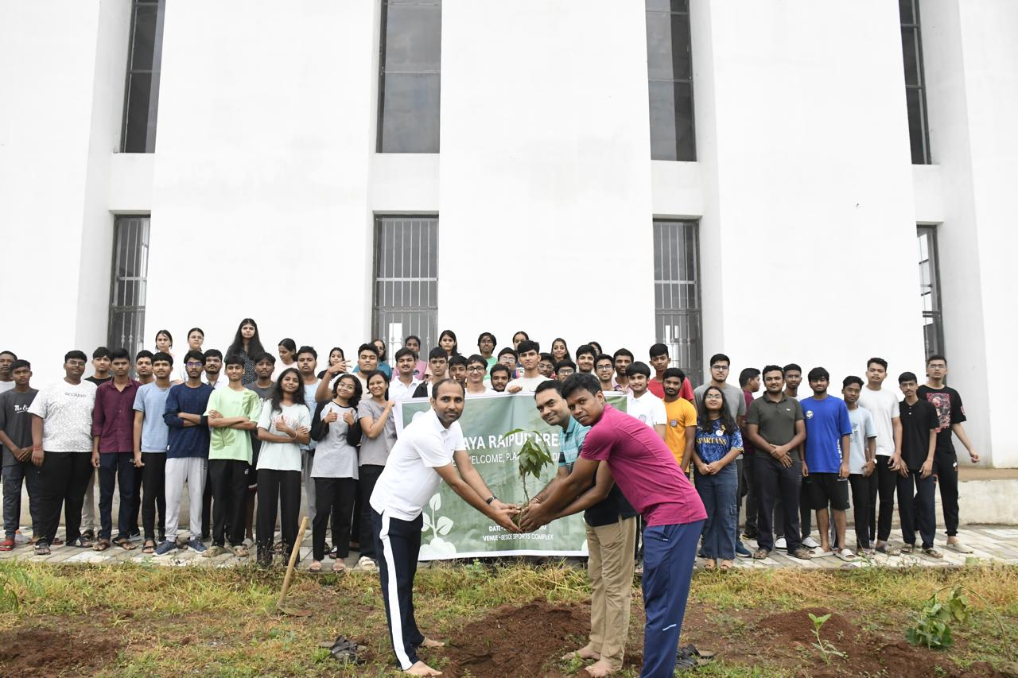

Picture of all participated members

NSS Activity No-06
National Sports Day 2025 Celebration at IIIT-NR
Name of NSS Unit: Dr. SPM IIIT Naya Raipur, Chhattisgarh, India
Name of the District: Raipur
Name of the NSS Program officer: Dr. Krishnanand Vishwakarma
Date of regular activity: 29-08-2025 to 31-08-2025
Brief Description of the Activity: The objective of the National Sports Day celebration at IIIT-NR was to promote fitness, teamwork, discipline, and sportsmanship among students and staff. The event aimed to encourage active participation in sports activities and to spread awareness about the importance of physical health under the Fit India and Khelo India initiatives.
The celebration included various sports events such as Cricket, Chess, and Basketball, organized at different venues across the campus. Students, teaching and non-teaching staff enthusiastically participated in the activities, making the event energetic and successful. The program was conducted under the guidance of Dr. Krishnanand Vishwakarma, NSS Program Officer, with active coordination and support from faculty and volunteers.
The pictures of the event are shown as below.
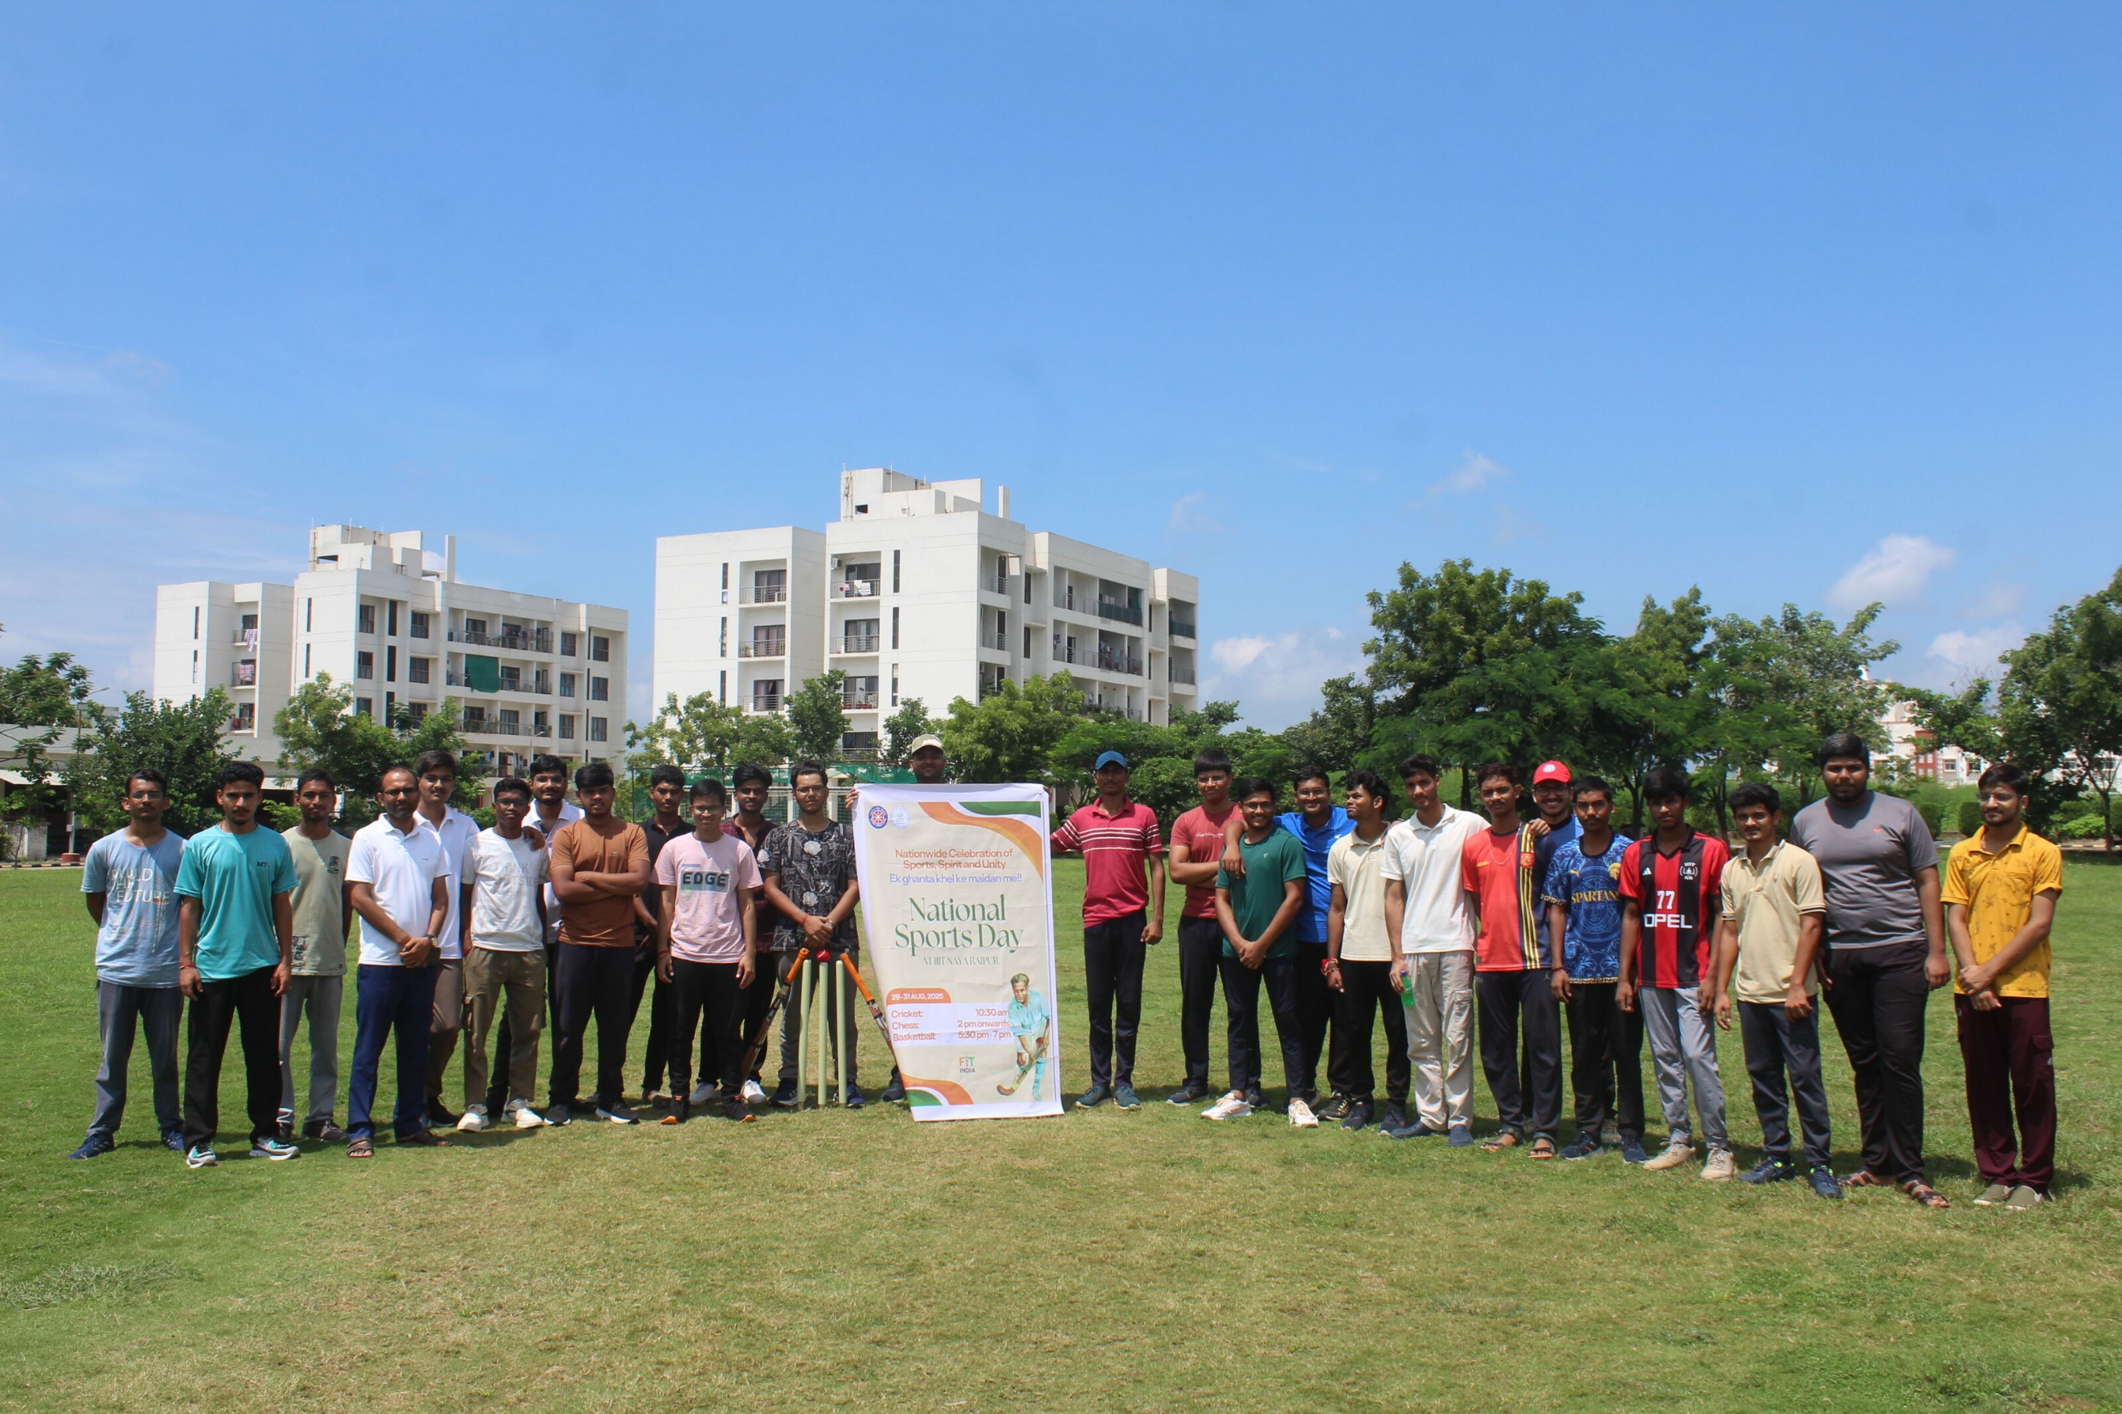

Picture of all participated members

NSS Activity No-07
Participation of IIIT-NR in New India Festival at IGKV Raipur
Name of NSS Unit: Dr. SPM IIIT Naya Raipur, Chhattisgarh, India
Name of the District: Raipur
Name of the NSS Program officer: Dr. Krishnanand Vishwakarma
Date of regular activity: 04-09-2025
Brief Description of the Activity: The objective of this event NEW INDIA FESTIVAL at
indira gandhi krishi vishwavidyalaya raipur on September 4 2025, is to celebrate the 11 years
complected on Modi government. In this events the IIIT-NR studnts also participated and
some of them becomes winners. The During this New India Festival competation, Tanshiq Bhattacharya, Divyansh Rangari, Yog Verma, Arpita Dash, Pranjal Gupta, Omkareshwar
are the winner of this events and Accolade by the Honarable Raipur sansad at NIT Raipur. In
this event, there are 6 students of IIIT-NR under the supervision of Dr Krishnanand
Vishwakarma, NSS PO, who are accolades. The picture of the event is shown as below.
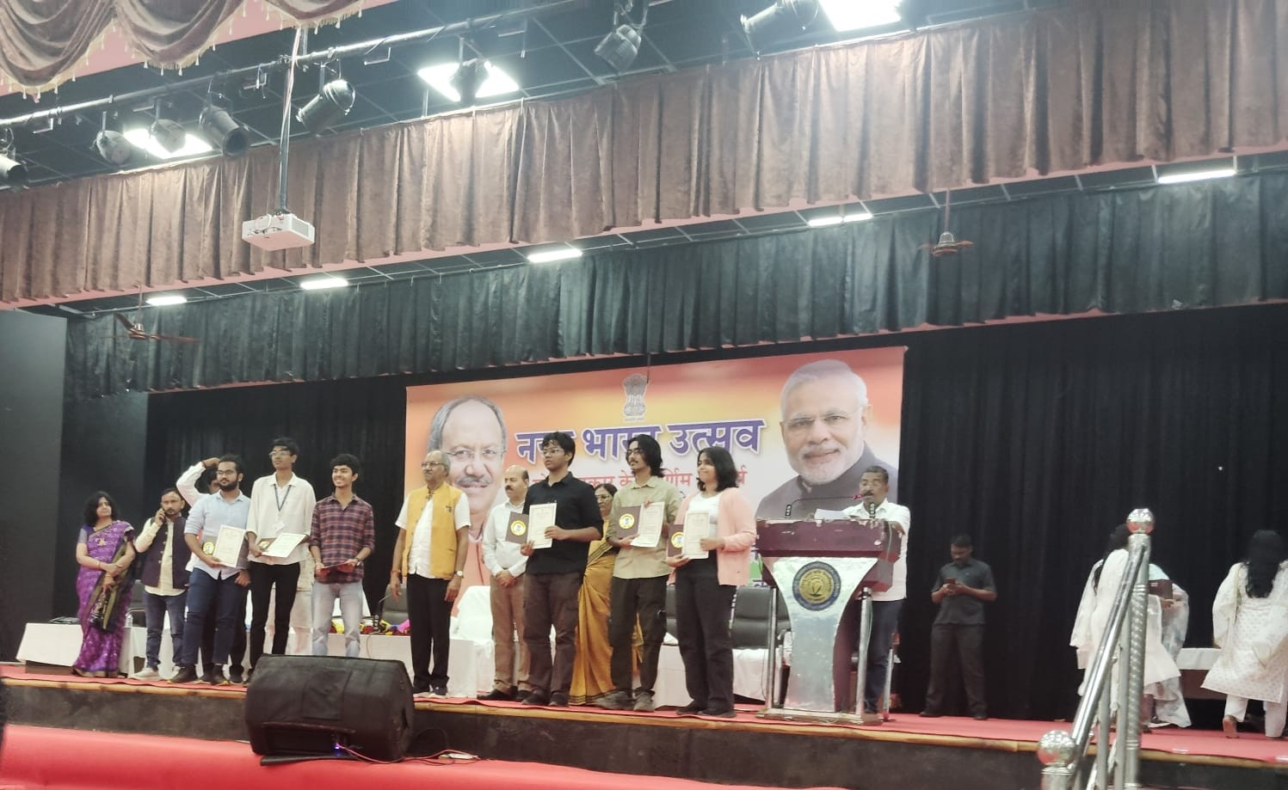

Picture of all participated members

NSS Activity No-08
Participation of IIIT-NR in RED RUN 2024 (State Level Marathon
Competition) at Raipur
Name of NSS Unit: Dr. SPM IIIT Naya Raipur, Chhattisgarh, India
Name of the District: Raipur
Name of the NSS Program officer: Dr. Krishnanand Vishwakarma
Date of regular activity: 07-09-2025
Brief Description of the Activity: The objective of this Red Marathon running at Raipur, is to
raise awaireness and protect the people infected from AIDS/HIV disease and know the
solution of how to control the spreading. This event is organized by the State Government of
Chhattisgarh in collaboration with the Red Ribbon Club, Raipur. The running started from
7:00 AM in Raipur city for 10 Km. The event was organized in the presence of Dr Neeta
Bajpayee, State NSS officer, Higher Education Department, Chhattisgarh. In this event, there
are 7 students of IIIT-NR under the supervision of Dr Krishnanand Vishwakarma, NSS PO,
who are participating. The picture of the event is shown as below.
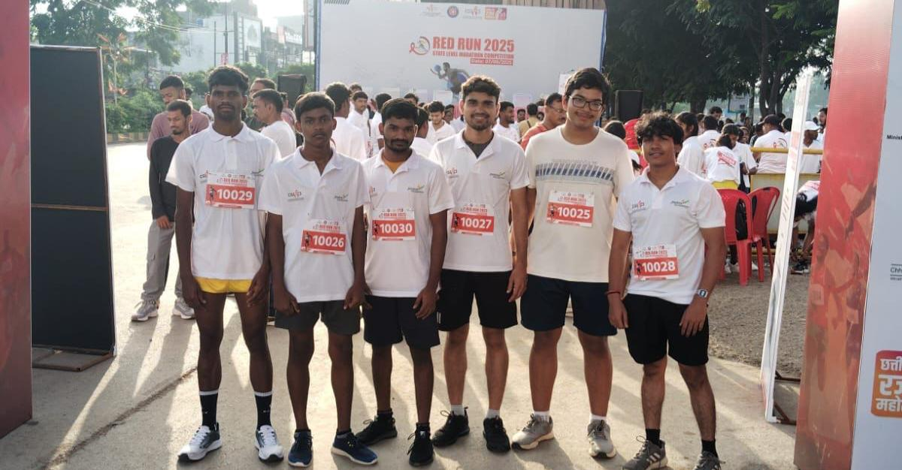
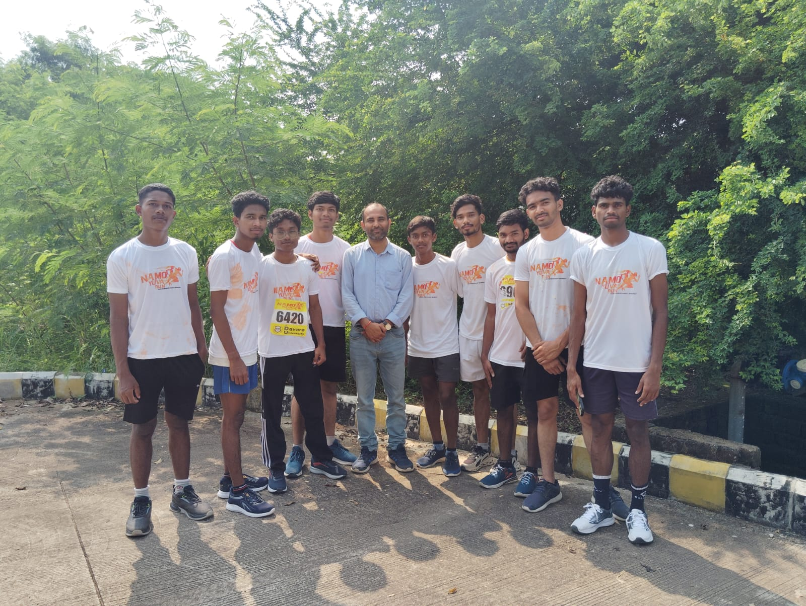

Picture of all participated members
NSS Activity No-09
Participation of IIIT-NR in Essay Competition at National Statistics Office (FOD), Raipur
Name of NSS Unit: Dr. SPM IIIT Naya Raipur, Chhattisgarh, India
Name of the District: Raipur
Name of the NSS Program officer: Dr. Krishnanand Vishwakarma
Date of regular activity: 19-09-2024
Brief Description of the Activity: The objective of the Essay Competition organized by the Regional Office (RO) Raipur, National Statistics Office (FOD), under the Ministry of Statistics and Programme Implementation (MoSPI), Government of India, was to celebrate the 75th Anniversary of the National Sample Survey (NSS) and to encourage students to express their views on topics related to statistics, surveys, artificial intelligence, and data-driven governance.
The competition was held on 19th September 2025 at the Meeting Hall, National Statistics Office (FOD), Raipur. The essay topics included themes such as the use of Artificial Intelligence in strengthening India’s statistical system, digital transformation in data collection, and the importance of statistics in policy-making and achieving Sustainable Development Goals.
Students of IIIT-NR actively participated in the competition under the supervision of Dr. Krishnanand Vishwakarma, NSS Program Officer. All participants received certificates of participation. The pictures of the event are shown as below.
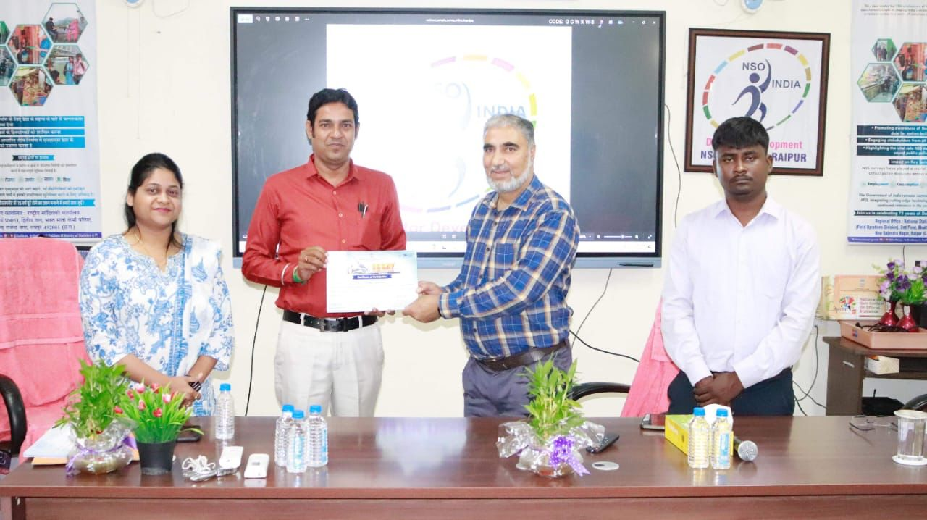

Picture of all participated members

NSS Activity No-10
Cleanliness Drive Conducted at IIIT Naya Raipur on Gandhi Jayanti
Name of NSS Unit: Dr. SPM IIIT Naya Raipur, Chhattisgarh, India
Name of the District: Raipur
Name of the NSS Program officer: Dr. Krishnanand Vishwakarma
Date of regular activity: 27-09-2025
Brief Description of the Activity: On the occasion of the birth anniversary of Mahatma Gandhi, a Cleanliness Drive was organized at IIIT Naya Raipur on 2nd October to promote the values of cleanliness, hygiene, and social responsibility in line with Gandhiji’s vision and the Swachh Bharat Abhiyan. The initiative aimed to spread awareness about the importance of maintaining a clean and healthy environment within the campus and in daily life.
The drive was led by Dr. K.N. Vishwakarma, NSS Program Officer, and Dr. Ramakrishna Bandi, Coordinator of CYTC, with encouragement and support from Dr. Lakhindar Murmu and Dr. Maifuz Ali, HOD (ECE). NSS volunteers actively participated with great enthusiasm in cleaning classrooms, corridors, common areas, and open spaces across the campus. Their dedicated efforts reflected a strong commitment towards environmental responsibility and community service.
The initiative not only enhanced the cleanliness of the campus but also instilled a sense of discipline and civic duty among the participants. The pictures of the participants are shown as below.

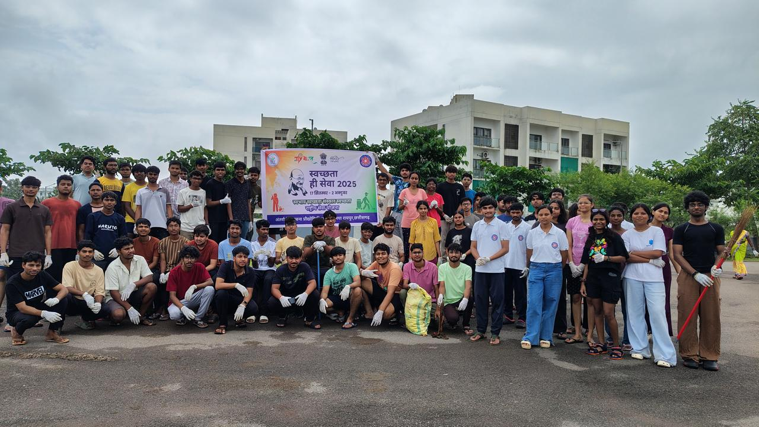
Picture of all participated members

NSS Activity No-11
Participation of IIIT-NR in the Education USA &amp; U.S. Consulate Session on Higher Studies in the U.S. and the Student Visa
Name of NSS Unit: Dr. SPM IIIT Naya Raipur, Chhattisgarh, India
Name of the District: Raipur
Name of the NSS Program officer: Dr. Krishnanand Vishwakarma
Date of regular activity: 30-11-2024
Brief Description of the Activity: The objective of the program “Education USA and US
Consultate Session on Higher Studies in the U.S. and the Student Visa” at IIIT- NR is to
familiarize the students with higher studies in the US. The session would be especially
relevant to those in the last two years of education, interested in pursuing master’s and
doctoral programs in the U.S. The informative session is more knowledgeable for the IIIT-NR
students, and they also interact with them regarding question answering. The session is
governed in the presence of NSS PO, Dr Krishnanand Vishwakarma, SAC president, Dr
Lakhindar Murmu, and Dean Academics, Prof. KG Srinivasa of IIIT Naya Raipur. The session
started from 4:00 PM to 7:00 PM at IIIT-NR, where there were 60-plus participants who
participated. The picture of the event is shown as below.
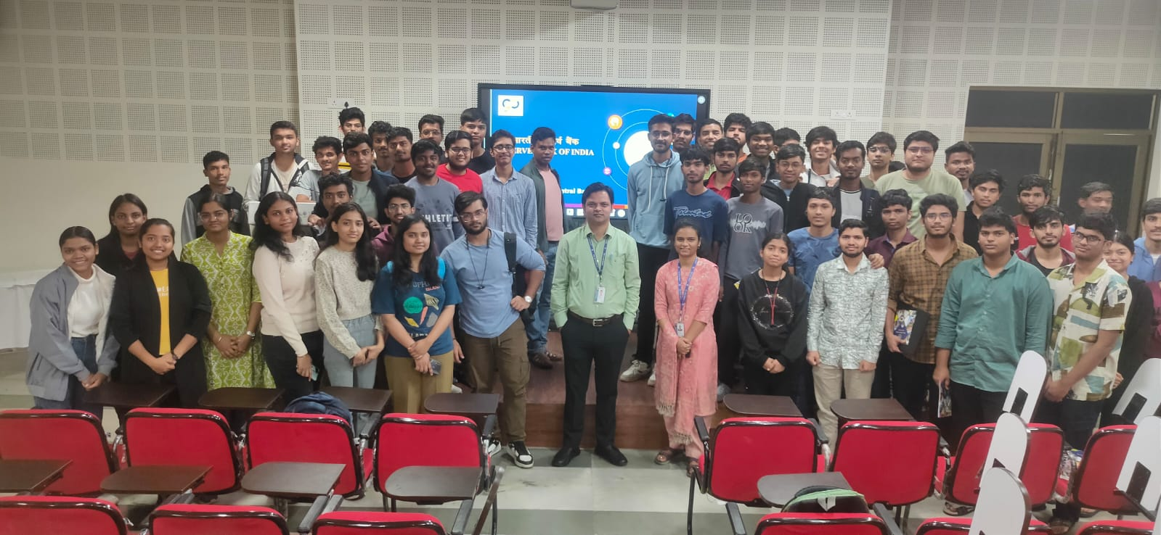
Picture of all participated members

NSS Activity No-12
HIV/AIDS Awareness campaign at IIIT-NR

Name of NSS Unit: Dr. SPM IIIT Naya Raipur, Chhattisgarh, India
Name of the District: Raipur
Name of the NSS Program officer: Dr. Krishnanand Vishwakarma/ Dr Lakhindar Murmu
Date of regular activity: 16-10-2025
Brief Description of the Activity:. The NSS Unit of IIIT Naya Raipur organized a Nukkad Natak (street play) on 16th October 2025 to spread awareness about HIV/AIDS. The activity was conducted under the RED RIBBON CLUB initiative as per the directions of the Higher Education Department of Chhattisgarh. The objective of the program was to educate students and staff about HIV/AIDS prevention, remove social stigma, and promote awareness about healthy and responsible practices.
The Nukkad Natak was performed at 4:30 PM near the Dr. SPM statue in the Main Academic Building. Students, faculty members, and staff actively participated and witnessed the performance. The initiative successfully conveyed important social messages through an engaging and impactful medium.
The pictures of the event are shown as below.
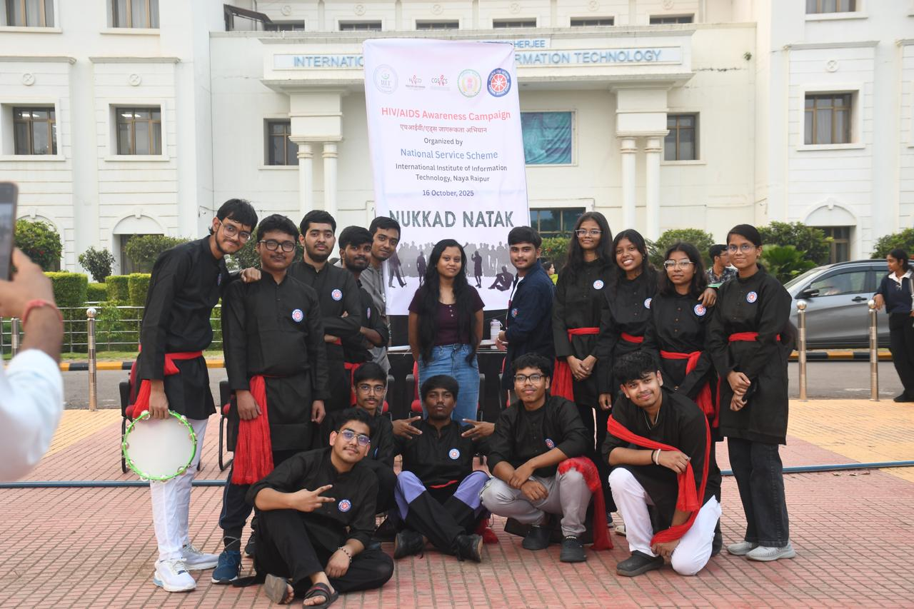

Picture of all participated members

NSS Activity No-13
Blood Donation Camp at IIIT-NR
Name of NSS Unit: Dr. SPM IIIT Naya Raipur, Chhattisgarh, India
Name of the District: Raipur
Name of the NSS Program officer: Dr. Krishnanand Vishwakarma/ Dr Lakhindar Murmu
Date of regular activity: 15-11-2025
Brief Description of the Activity: The NSS Unit of IIIT Naya Raipur organized a Blood Donation Camp on 15th November 2025 in collaboration with AIIMS Raipur, Chhattisgarh and HDFC Bank. The objective of the camp was to promote voluntary blood donation and spread awareness about its life-saving impact.
The camp was conducted at 10:00 AM in the Incubation Centre of IIIT-NR. Students, research scholars, faculty members, and staff actively participated in the initiative. The activity encouraged social responsibility and humanitarian service, emphasizing that one unit of donated blood can save up to three lives.
The pictures of the camp are shown as below.

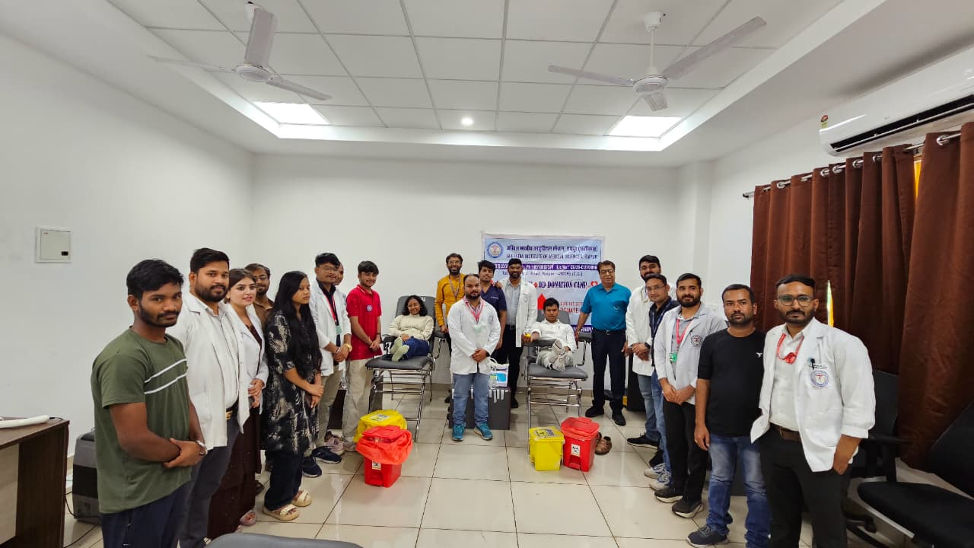

Picture during the Events

Dental Check-up at IIIT-NR

Name of NSS Unit: Dr. SPM IIIT Naya Raipur, Chhattisgarh, India
Name of the District: Raipur
Name of the NSS Program officer: Dr. Krishnanand Vishwakarma
Date of regular activity: 21-01-2026
Brief Description of the Activity: The NSS Unit of IIIT Naya Raipur organized a Free Dental Check-up Camp on 21st January 2026 in association with the National Tobacco Control Programme (NTCP), National Oral Health Programme (NOHP), and Rakhi Medical Centre, Naya Raipur, Chhattisgarh. The objective of the camp was to promote oral hygiene awareness, encourage preventive dental care, and educate participants about the harmful effects of tobacco consumption.
The camp was conducted from 10:00 AM to 1:30 PM near the Medical Centre (Ground Floor) at IIIT-NR. Students, faculty members, and staff actively participated in the health initiative. The program successfully spread awareness regarding oral health and preventive care practices.
The pictures of the camp are shown as below.

Picture during the Events

NSS Activity No-15
Republic Day Celebrations at IIIT-NR

Name of NSS Unit: Dr. SPM IIIT Naya Raipur, Chhattisgarh, India
Name of the District: Raipur
Name of the NSS Program officer: Dr. Krishnanand Vishwakarma
Date of regular activity: 07-01-2025
Brief Description of the Activity: Republic Day was celebrated with great patriotism and enthusiasm at the IIIT-NR campus on 26th January 2026. The event aimed to commemorate the adoption of the Constitution of India and to promote national unity, integrity, and constitutional values among students and staff.
The celebration was graced by the Chief Guest, Dr. Om Prakash Vyas, Director of IIIT-NR. Faculty members, staff along with their family members, and students assembled at the entrance of the Academic Building at 9:00 AM to participate in the ceremony. The program included flag hoisting, followed by speeches and cultural activities reflecting the spirit of the nation.
The celebration fostered a deep sense of pride, unity, and responsibility towards the country among all attendees. The pictures of the celebration are shown as below.

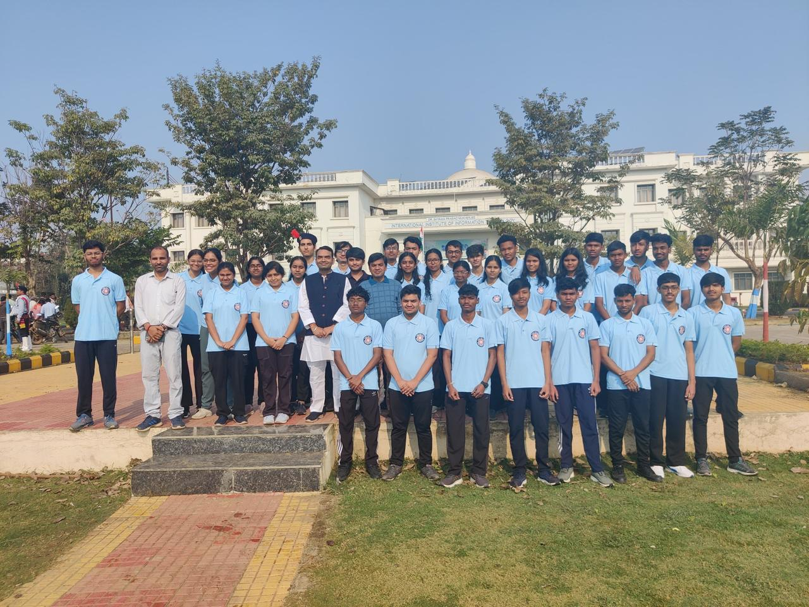

Pictures during the Events

